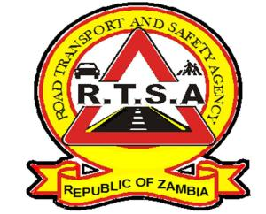

**ROAD TRANSPORT AND SAFETY AGENCY**

**PRESS STATEMENT**

**RTSA CAUTIONS NCWALA GOERS TO OBSERVE TRAFFIC RULES AND**

**REGULATIONS**

**LUSAKA**, **20th February,** **2025**. The Road Transport and Safety Agency (RTSA) would like to urge motorists and all road users to observe traffic rules and regulations ahead of the Ncwala Traditional Ceremony of the Ngoni speaking people scheduled for this Saturday, 22nd February, 2025 at Mutenguleni in Chipata.

With an expected increase in both vehicular and pedestrian traffic on the Great East road, there is heightened risk of road traffic crashes if traffic rules are not adhered to by road users.

Motorists and Riders are advised to exercise patience on the road, not to drink and drive, avoid overloading and speeding. Pedestrians and cyclists are also reminded to be extra cautious and observe all road traffic rules during this period.

The RTSA and the Zambia Police Service Traffic Section will conduct intensified enforcement activities along the Great East Road to ensure there is adherence to traffic rules and regulations.

The Agency would like to call upon members of the public to continue making use of the RTSA National Call Centre by reporting all bad, careless and dangerous drivers on the Toll-Free line – 983 and the WhatsApp line 0965-429499.

**Issued and authorised for publication by Date: 20th February, 2025**

**Mukela Mangolwa**

**Acting Head-Public Relations**

**Road Safety House**

**Dedan Kimathi Road**

**LUSAKA.**